Sponsor: Anova Study: ABC/BBC
Table 5.0
Analysis of Time to Initial PSGA Success* in Weeks
Safety Population
ARM A ARM B ARM C ARM D
(N=36) (N=38) (N=38) (N=38)
-------------------------------------------------------------------------------------------------------
Number of patients with PSGA <= 1 5 11 16 11
Number of Censored Subjects (PSGA > 1) 31 26 21 26
Kaplan-Meier estimates
25th percentile (weeks) - 12 8 16
95% Confidence Interval** (-, -) (6, -) (6, 16) (6, -)
Median (weeks) - - - -
95% Confidence Interval** (-, -) (-, -) (16, -) (-, -)
75th percentile (weeks) - - - -
95% Confidence Interval** (-, -) (-, -) (-, -) (-, -)
Results of Proportional Hazards Regression Analysis
Hazard Ratio (Each Treatment Group - ARM A)*** - 2.51 3.71 2.37
P-value - 0.089 0.011 0.109
95% CI of Hazard Ratio - (0.87, 7.21) (1.36, (0.82, 6.83)
10.13)
Program: Surv_Table.R
* Success: PSGA <= 1: PSGA > 1
** Based on R survival package survfit() function
*** Based on proportional hazards model with treatment indicator variables as explanatory variables
Note: The end-point is cure of the disease (PSGA <= 1).
The probability of remaining diseased (PSGA > 1) defines the survival function
Note: A subject who is not cured by the end of 12 weeks or is lost
to follow provides a censored observation for the analysis.
"-" = Not Applicable
Date Produced: 20Apr25 19:08 Page 1 of 2
Sponsor: Anova Study: ABC/BBC
Figure 5.0
Kaplan-Meier Plot for Time to Initial PSGA Success (PSGA <= 1)
Safety Population
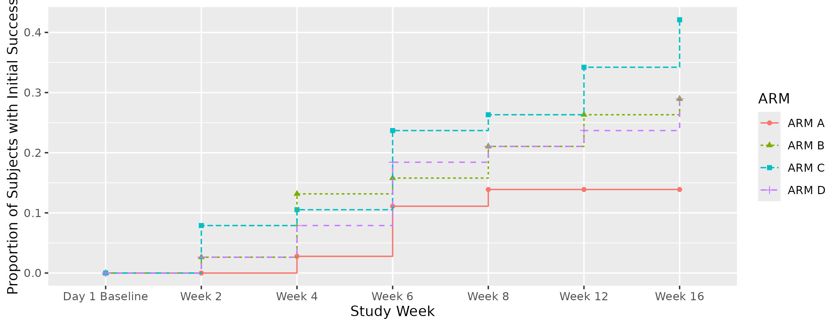
Program: Surv_Table.R
* Success: PSGA <= 1: PSGA > 1
** Based on R survival package survfit() function
*** Based on proportional hazards model with treatment indicator variables as explanatory variables
Note: The end-point is cure of the disease (PSGA <= 1).
The probability of remaining diseased (PSGA > 1) defines the survival function
Note: A subject who is not cured by the end of 12 weeks or is lost
to follow provides a censored observation for the analysis.
"-" = Not Applicable
Date Produced: 20Apr25 19:08 Page 2 of 2

